When the Skies Opened:

Investigating the 2022 Pakistani Flood Catastrophe

**By Faizan Faisal**

Contents

1. Introduction 3

2. Consequences 3

3. Rainfall 4

3.1 Monsoon 4

3.2 Arabian Sea Depression 8

4. Global Warming 9

4.1 Heat Waves 9

4.1.1 Visualizing Trends 9

4.1.2 Predictability of Temperature 10

4.2 Glacial Melt 11

5. Conclusion 12

6. References 13

# Introduction

The threat of flooding has escalated in South Asia due to heightened susceptibility and exposure. The massive flood in Pakistan in August 2022 serves as a stark example of the potential scale and destruction that may continue to grow in a warming climate. The 2022 flood's impact on Pakistan's southern provinces was unprecedented, surpassing recent incidents in terms of extensive geographical and temporal reach. This event resulted in the second-highest human death toll (in Pakistan) while being the foremost incident that displaced approximately 33 million individuals within the country.

As per a preliminary evaluation by the Atlantic Council's Uzair Younus and economist Ammar Khan, the direct harm to infrastructure, residences, livestock, and agriculture exceeds $3 billion – a staggering sum for a developing nation such as Pakistan. By analyzing observations and climate forecasts, this report explores the potential origins of the floods (United States Institute of Peace). The 2022 flood in Pakistan emphasizes the adaptation difficulties South Asia faces, as well as the pressing need for climate mitigation measures to decrease the likelihood of similar events.

# Consequences

Half a year following the unparalleled flooding that devastated Pakistan, over 10 million individuals residing in the impacted regions continue to lack access to clean drinking water, compelling them to resort to using and consuming potentially harmful, disease-carrying water.

Approximately 20.6 million people, 9.6 million of whom are children, require humanitarian aid. Several of the most severely affected areas are among Pakistan's most susceptible regions, where children already face high levels of malnutrition, limited access to water and sanitation, and low school attendance.

The recovery process for families dealing with the overwhelming destruction will span months, if not years. The floods impacted 33 million people, claimed over 1,700 lives, and damaged or destroyed more than 2.2 million homes. The water infrastructure in the affected zones was severely damaged, forcing over 5.4 million people, including 2.5 million children, to depend entirely on polluted water from ponds and wells. (UNICEF)

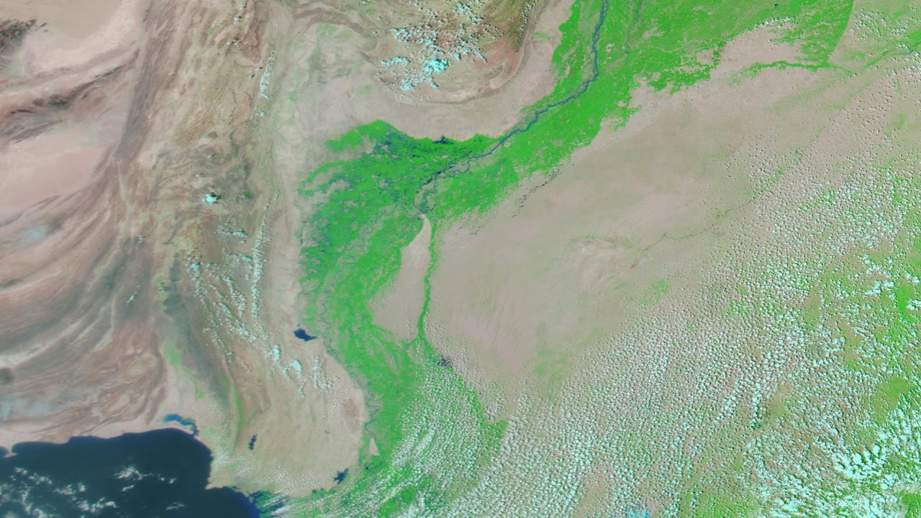

Figure 1. Satellite Image by NASA 2021

Figure 2. Satellite Image by NASA 2022

# Rainfall

## 3.1 Monsoon

Between June and August, Pakistan experienced an extraordinary 190 percent of its typical rainfall. In July alone, rainfall surpassed the average monsoon total by approximately 26 percent, making it the rainiest July on record since 1961. The intense precipitation led to saturated soil, inhibiting the ground's ability to absorb further water during August's storms. August is typically the peak of monsoon season, and it continued to witness remarkable downpours and flooding.

U.N. Secretary-General António Guterres [said](https://www.cnn.com/2022/08/29/asia/pakistan-flood-damage-imf-bailout-intl-hnk/index.html), “The Pakistani people are facing a monsoon on steroids”. The regions of Baluchistan and Sindh experienced extraordinarily intense rainfall, leading to extensive and widespread damage. Between mid-June and August, Baluchistan received 430 percent of its typical rainfall, while Sindh experienced 460 percent of its average precipitation. Approximately 50 different urban areas witnessed monthly rainfall levels substantially higher than the norm. (Washington Post)

The figures below show the drastic spike in the monsoon rainfall in 2022 as recorded by different organizations:

Figure 3. Average Precipitation in major cities of Paksitan

|  |  |
| --- | --- |
| **Legend for Abbreviations** | |
| CPC | Climate Prediction Center |
| IMERG | Integrated Multi-satellite Retrievals (NASA) |
| ERA5 | European Centre for Medium-Range Weather Forecasts |
| Station | [Pakistan Meteorological Department](https://www.pmd.gov.pk/) |

Table 1. Abbreviations in Figure 3.

Monsoon in Pakistan is primarily due to the seasonal reversal of winds and the differential heating of land and water. This weather phenomenon typically occurs during the summer months, between June and September.

During the summer, the Indian subcontinent experiences intense heating from the sun, causing the land to become much warmer than the surrounding Indian Ocean. This temperature difference leads to the creation of a low-pressure system over the subcontinent. As a result, moist air from the Indian Ocean is drawn towards the landmass.

The moisture-laden winds from the southwest Indian Ocean are forced to rise as they encounter the mountain ranges of the Western Ghats and the Himalayas. As the air rises, it cools and condenses, forming clouds and eventually leading to heavy rainfall across the region, including Pakistan.

Figure 4. and 5. shows the typical path of Monsoon Winds that enter through the north of Pakistan. In comparison to this, Figure 6. by Pakistan Meteorological Department shows the path of these winds in the year 2022.

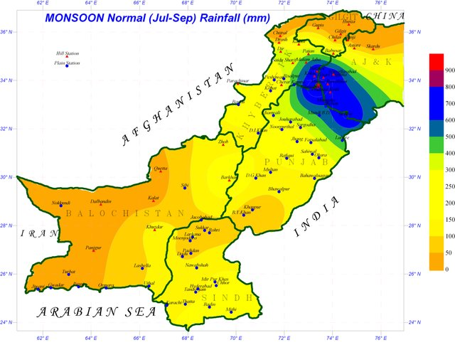

Figure 4. Typical Monsoon Regions Figure 5. Typical Monsoon Tracks

Figure 6. Monsoon Tracks Observed in 2022 (PMD)

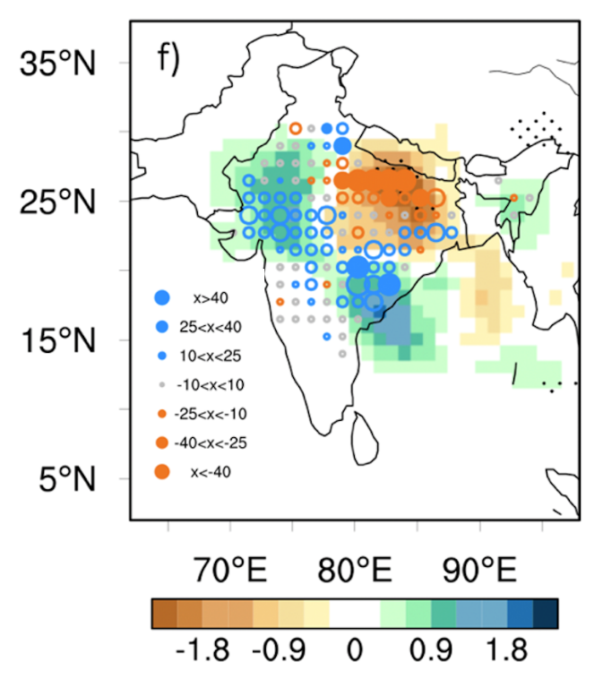This phenomenon can be linked to a study conducted in 2021 by You and Ting which showed that in the period 1979 – 2018, the secular variation of rainfall extremes over India is characterized by a dipole-like pattern with increased rainfall extremes over south-central India and decreased rainfall extremes over north-central India. It shows that, since the inception of satellite records in the late 1970s, the pathways of low-pressure systems have experienced a southward shift. The study's map, as seen below, demonstrates the altered systems that contribute to heightened precipitation events (represented by blue dots) along a southeastern to northwestern corridor, spanning from Andhra Pradesh to Rajasthan, and potentially extending into Pakistan. Figure 7. Change in Rainfall Patterns (India)

Simulations of streamflow from various hydrological models indicate that extreme rainfall lasting several days was the main cause of the floods. The heavy rain fell on already saturated soil, a result of persistent rainfall in July and early August. This combination of extreme rainfall and wet underlying conditions was the primary factor behind Pakistan's 2022 flood. The findings suggest that an extreme rain event in the southern regions, which had a 100-year recurrence interval, served as an immediate catalyst for the flood (Nanditha et al., 2023).

## 3.2 Arabian Sea Depression

The heatwaves (Section 4.1) occurred simultaneously with another remarkable incident – a low-pressure system, or depression, in the Arabian Sea, leading to heavy rainfall in Pakistan's coastal regions as early as June. Athar Hussain, a climate scientist at COMSATS University, notes that it is uncommon for such extensive depression systems to appear there. The atypical conditions were further intensified by the monsoon's premature onset on June 30th, which caused more widespread and extended rainfall throughout a broader area, according to Andrew King, a climatologist at the University of Melbourne in Australia. (Scientific American, 2022)

# Global Warming

## 4.1 Heat Waves

### 4.1.1 Visualizing Trends

The 2022 heat wave in India and Pakistan resulted in hottest March in the subcontinent since 1901. The historical temperature from the PMD archives of Pakistan revealed the anomalous nature of 2022 temperature between March and May. Figure 8. shows the monthly temperatures up till February 2023.

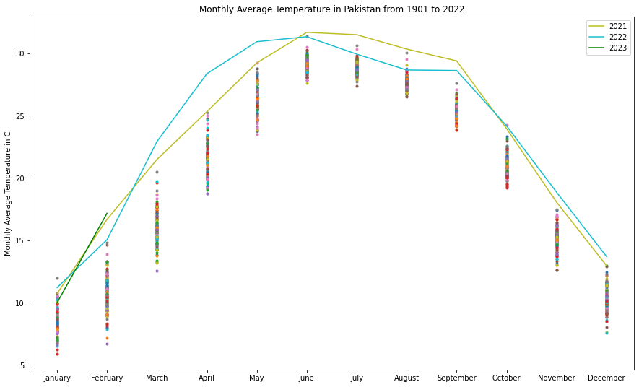

Figure 8. Monthly Average Temperatures (1901 – 2022)

During the months of April and May, numerous locations experienced extended periods of temperatures exceeding 40°C. In one exceptionally hot day in May, the city of Jacobabad even reached a temperature of 51°C. In the study “Climate Change made devastating early heat in India and Pakistan 30 times more likely” conducted by a team of climate scientists, concluded that heatwaves like this will become more common and hotter. It also concluded that the heatwave was intensified and made more probable due to climate change caused by human activities.

Figure 9. shows visualizes the trend in the average annual temperature of Pakistan from 1901 – 2022. The trend shows a sharp rise in temperatures in the last two decades as a result of global warming. The meteoric rise in the average temperature in 2022 can also be observed.

Figure 9. Trend of yearly average temperature (1901 – 2022)

### 4.1.2 Predictability of Temperature

In order to explore whether such temperature anomalies can be predicted, temperatures from 2010 – 2022 were forecasted using LSTM neural network. LSTMs have shown to give better performance than the traditional ARIMA and SARIMA in the domain of time series forecasting (Feng, 2022). Figure 10. illustrates how deep learning-based time series forecasting can quite accurately extrapolate temperature trends. This would enable us to simulate the effects of future temperatures with reasonable accuracy, providing an opportunity to take early action to prevent potential disasters.

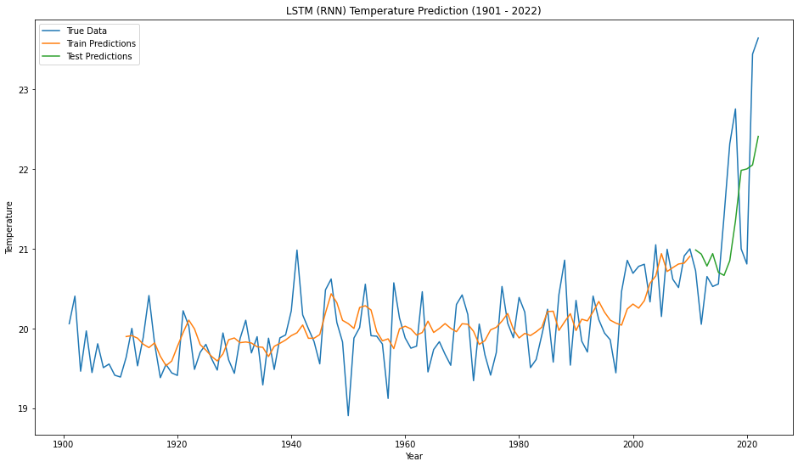

Figure 10. LSTM based temperature time series forecasting

## 4.2 Glacial Melt

The extreme heat has caused glaciers in the northern mountainous areas to melt, leading to an increased volume of water entering streams that ultimately contribute to the Indus River, according to Athar Hussain. As Pakistan's longest river, the Indus stretches from the north to the south of the country, supplying water to urban and rural areas and extensive agricultural land.

The exact quantity of additional glacial meltwater entering rivers this year is uncertain, but Hashmi observed high water levels and murky water in the Hunza River, a tributary of the Indus, during a visit to elevated glacier areas in July. The presence of mud indicates rapid melting, as swift water gathers sediment while flowing downstream. In some cases, glacial lakes have breached the ice barriers that usually contain them, unleashing a hazardous surge of water. (Scientific American, 2022)

Pakistan is highly susceptible to glacial lake outburst floods (GLOF) due to the presence of over 3,000 glacial lakes in its northern mountain ranges. While the glacial melt from the March-May heatwave may have worsened the flooding in conjunction with the extreme rainfall, it was not the principal driver (Nanditha et al., 2023).

# Conclusion

As shown in the study by World Weather Attribution, climate change made devastating early heat in India and Pakistan 30 times more likely. The subcontinent (Pakistan and India) experienced the hottest March (in 120 years) as a result of global warming, creating a low-pressure zone above land. This resulted in strong reversal of winds due to the differential heating of land and water. As shown by the study You and Ting, the period after 1979 has seen an increase in rainfall extremes over south-central India and decreased rainfall extremes over north-central India, extending to southern Pakistan. This can be observed in Meteorological Department’s data for 2022. The anomalous heatwaves in March and April resulted in increased rates of glacial melt as noted by Hussain.

The monsoon's premature onset at the end of June was further intensified by the rare event of the Arabian Sea Depression which led to more rainfall in southern Pakistan. The intense precipitation led to saturated soil, inhibiting the ground's ability to absorb further water during August's storms as demonstrated by Nanditha et al., resulting in the catastrophe.

# References

J. S. Nanditha, Anuj Prakash Kushwaha, Rajesh Singh et al. (2023). The Pakistan Flood of August 2022: Causes and Implications. Earth's Future. <https://doi.org/10.1029/2022EF003230>

UNICEF. (2022). Devastating floods in Pakistan. <https://www.unicef.org/emergencies/devastating-floods-pakistan-2022>

Carbon Brief. (2022). Climate change likely increased extreme rainfall that led to Pakistan flooding. <https://www.carbonbrief.org/climate-change-likely-increased-extreme-rainfall-that-led-to-pakistan-flooding/>

Carbon Brief. (2022). How the South Asian monsoon is changing in a warming climate. Carbon Brief. <https://www.carbonbrief.org/guest-post-how-the-south-asian-monsoon-is-changing-in-a-warming-climate>

United States Institute of Peace. (2022). Why is Pakistan drowning? <https://www.usip.org/publications/2022/09/why-pakistan-drowning>

Waqas, A., Khan, A., & Akbar, M. (2022). Extreme weather events in Pakistan: Impacts on health and the way forward. Frontiers in Public Health, 10, 946563. <https://doi.org/10.3389/fpubh.2022.946563>

CNN. (2022). Pakistan floods form 'inland lake' visible from space as climate disasters push country to brink. <https://edition.cnn.com/2022/08/31/asia/pakistan-floods-forms-inland-lake-satellite-intl-hnk/index.html>

World Meteorological Organization. (n.d.). Climate change made heatwaves in India and Pakistan 30 times more likely. <https://public.wmo.int/en/media/news/climate-change-made-heatwaves-india-and-pakistan-30-times-more-likely>

World Weather Attribution. (n.d.). Climate change made devastating early heat in India and Pakistan 30 times more likely. <https://www.worldweatherattribution.org/climate-change-made-devastating-early-heat-in-india-and-pakistan-30-times-more-likely/>

Scientific American. (n.d.). Why are Pakistan's floods so extreme this year? <https://www.scientificamerican.com/article/why-are-pakistan-rsquo-s-floods-so-extreme-this-year/>

Kaggle. (n.d.). Pakistan Temperature Dataset. <https://www.kaggle.com/datasets/zusmani/pakistan-temperature>

France24. (2022, August 31). First came the heat waves, then the floods: Why Pakistan is on the frontline of the climate crisis. France 24. <https://www.france24.com/en/asia-pacific/20220831-first-came-the-heat-waves-then-the-floods-why-pakistan-is-on-the-frontline-of-the-climate-crisis>

You, Y., & Ting, M. (2021). Observed trends in the South Asian monsoon low‐pressure systems and rainfall extremes since the late 1970s. *Geophysical Research Letters*, *48*(9), e2021GL092378.

Pakistan Meteorological Department. (n.d.). Home. <https://www.pmd.gov.pk/en/>